PAT Task

Mutendi Sambaza

developer



Design Document

MediSeek Hospital Management System

Contents

**Interface Design** 3

Welcome Pages 3

Emergency Directory 4

Emergency Directory – Selection GUI 4

Emergency Directory – Specialist and Residency 4

Login Pages 5

User Selection 5

Respective Login Pages 6

Doctor Page 7

View Patients 7

View Appointments 8

View Patient History 9

Personal Information 9

Pharmacist Page 10

View Patients 10

Issue Prescription 11

View Medicine Dispensary 12

View Patient History 12

Personal Information 13

Receptionist Page 14

View Patients 14

Add an Appointment 15

View Staff 16

View Appointments 17

View Add a Patient 18

View Patient History 18

Personal Information 19

Administrator Page 20

View Patients 20

View Staff 21

View Specialty Codes 22

View Appointments 22

Add new Patient 23

Add New Staff 23

Personal Information 24

**Program Flow and Sequencing** 25

**Class Diagrams** 27

**Persistent Storage Design** 31

**Explanation of Secondary Storage Design** 33

**Explanation of Primary Data Structure Related to Secondary Storage** 33

tblStaff 33

tblPatients 33

tblAppointments 33

tblDirectory 33

tblMedicine 33

tblResidence 33

tblSpecialty 34

# **Interface Design**

## A picture containing text, display, screenshot Description automatically generatedA picture containing chart Description automatically generatedWelcome Pages

|  |  |  |
| --- | --- | --- |
| **GUI Component and Name** | **Action performed** | **Data validation required** |
| **Button:** Login | Redirects to the User Selection page | N/A |
| **Button:** Emergency Specialist Directory | Redirects to the Emergency Specialist Directory selection page | N/A |

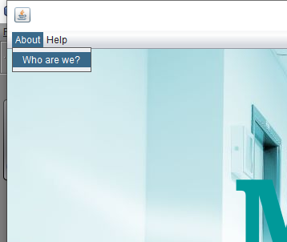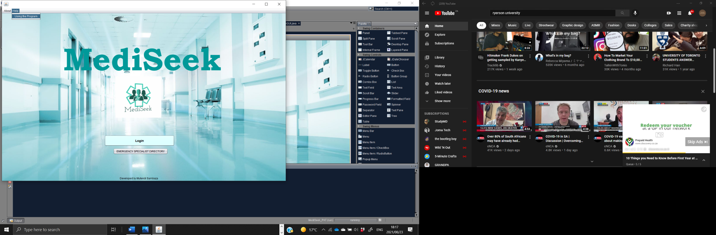

|  |  |  |
| --- | --- | --- |
| **GUI Component and Name** | **Action performed** | **Data validation required** |
| **Button:** About – Who Are We? | Opens a word document containing the vision for MediSeek | N/A |
| **Button:** Help – Using the Program | Opens a word document containing the guidance on navigating the program | N/A |

## Emergency Directory

### Graphical user interface, text, chat or text message Description automatically generatedEmergency Directory – Selection GUI

|  |  |  |
| --- | --- | --- |
| **GUI Component and Name** | **Action performed** | **Data validation required** |
| **Button:** Return to Login | Redirects the user back to the Welcome Page | N/A |
| **Button:** Find Specialist | Redirects the user back to the Emergency Specialist Page | N/A |
| **Button:** Find Residency | Redirects the user back to the Emergency Residency Page | N/A |

### A picture containing text, computer, screenshot Description automatically generatedEmergency Directory – Specialist and Residency

|  |  |  |
| --- | --- | --- |
| **GUI Component and Name** | **Action performed** | **Data validation required** |
| **Button:** Back | Redirects the user back to the Emergency Directory – Selection | N/A |
| **Button:** See Specialist Info | Once a record has been selected, Displays all the Specialist’s information in the relevant fields | Check to see that a record has been selected, appropriate message will show if not |

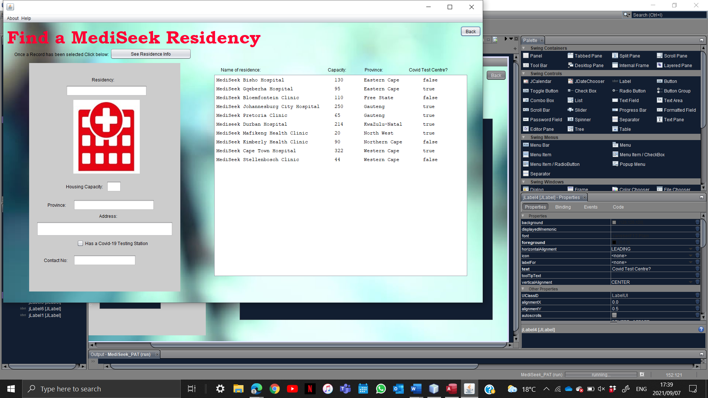

|  |  |  |
| --- | --- | --- |
| **GUI Component and Name** | **Action performed** | **Data validation required** |
| **Button:** Back | Redirects the user back to the Emergency Directory – Selection | N/A |
| **Button:** See Residence Info | Once a record has been selected, Displays all the Residence’s information in the relevant fields | Check to see that a record has been selected, appropriate message will show if not |

## Login Pages

### A screenshot of a computer Description automatically generated with medium confidenceUser Selection

|  |  |  |
| --- | --- | --- |
| **GUI Component and Name** | **Action performed** | **Data validation required** |
| **Button:** Doctor | Redirects User to the Doctor Login Page | N/A |
| **Button:** Pharmacist | Redirects User to the Pharmacist Login Page | N/A |
| **Button:** Receptionist | Redirects User to the Receptionist Login Page | N/A |
| **Button:** Administrator | Redirects User to the Administrator Login Page | N/A |

### A picture containing text Description automatically generatedDiagram Description automatically generatedDiagram Description automatically generated with medium confidenceDiagram Description automatically generated with medium confidenceRespective Login Pages

|  |  |  |
| --- | --- | --- |
| **GUI Component and Name** | **Action performed** | **Data validation required** |
| **Button:** Back | Redirects the user back to the User Selection page | N/A |
| **Button:** Login | Cross references the staff database and if there are the relevant matches of credentials then the program redirects the User to their respective main pages | * Both Staff ID & Password fields are filled * Staff ID Exists * Password is correct   appropriate message will show if anything is not carried out correctly |

## Doctor Page

### Graphical user interface, application Description automatically generatedView Patients

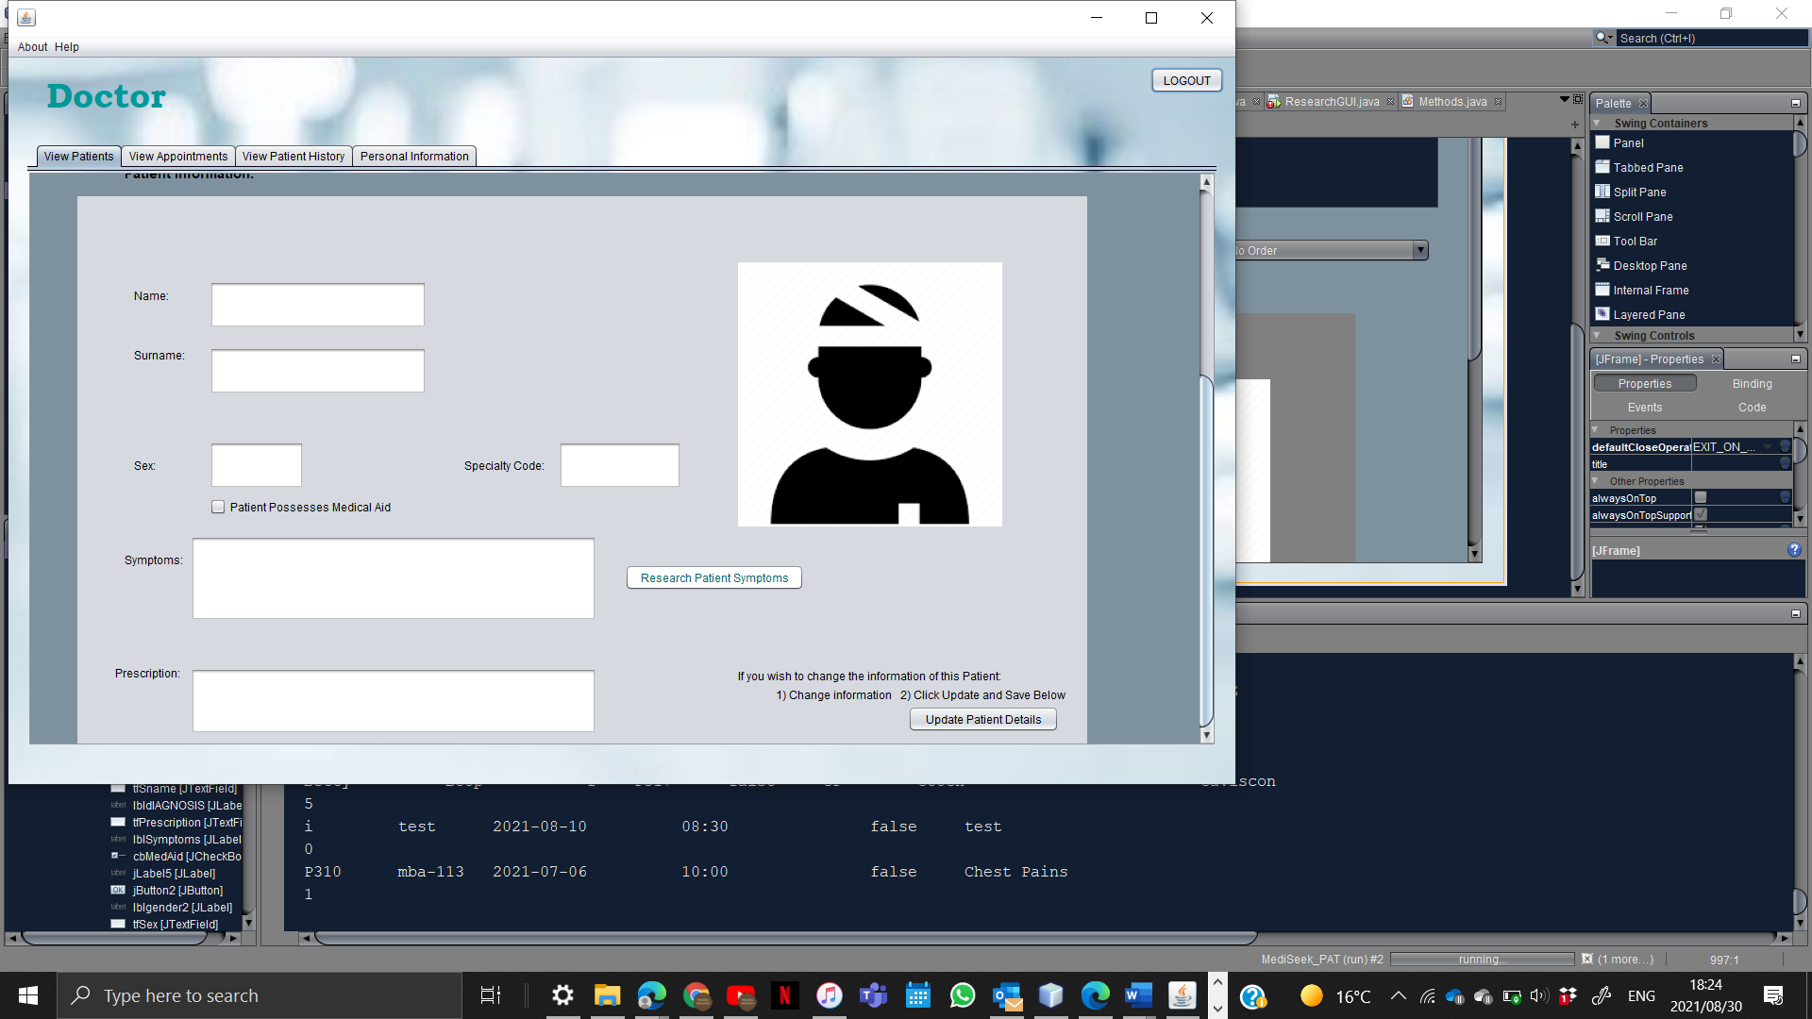

|  |  |  |
| --- | --- | --- |
| **GUI Component and Name** | **Action performed** | **Data validation required** |
| **Button:** Logout | Redirects the user back to the User Selection Page | N/A |
| **Combo Box:** PatientsOrder | Clears and re-orders the list according to desired selections | N/A |
| **Button:** Refresh | Clears the ordered list and randomly orders the list with all patients | N/A |
| **Button:** Search Patient | Searches for and displays a specific patient record in the list | Patient ID has been entered; appropriate message will show if not carried out correctly |
| **Button:** See Patient Info | Displays the selected Patient’s information in the respective fields for view | Patient record has been selected; appropriate message will show if not carried out correctly |
| **Button:** Update Patient | Updates the Patient’s Record and Details in real time | Patient Record has been selected; appropriate message will show if not carried out correctly |
| **Button:** Research Patient’s Symptoms | Takes the details within the Symptoms Filed and searches them on google | Record has to be selected and displayed ie There has to be values in the field for the search to go through. ; appropriate message will show if not carried out correctly |

### View Appointments

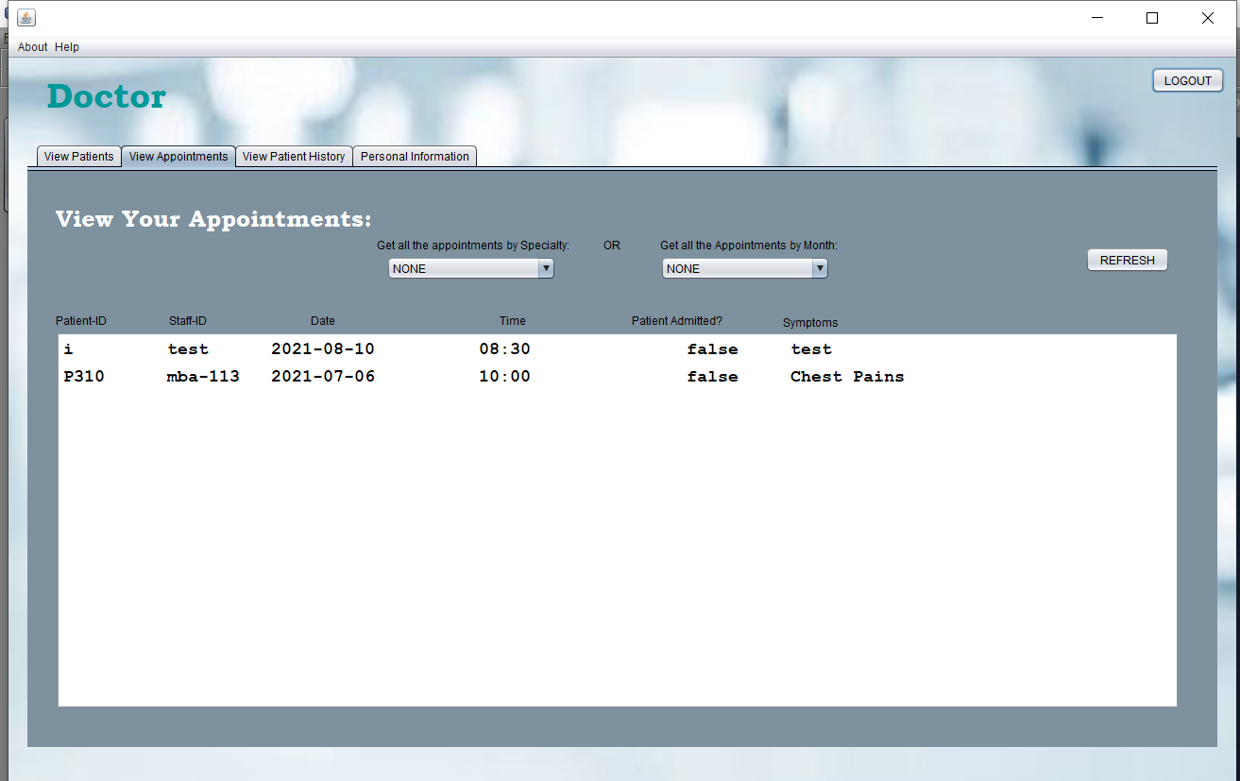

|  |  |  |
| --- | --- | --- |
| **GUI Component and Name** | **Action performed** | **Data validation required** |
| **Combo Box:** Monthly Order | Clears and re-orders the Appointments according to desired Month of the year | N/A |
| **Combo Box:** Specialty Order | Clears and re-orders the Appointments according to desired Specialty | N/A |
| **Button:** Refresh | Displays all the appointments in no particular order | N/A |

### View Patient History

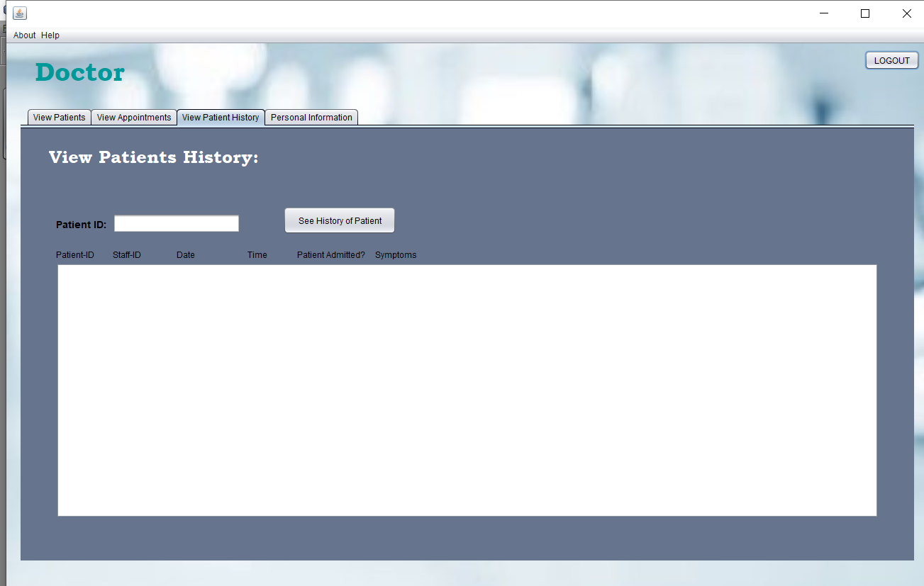

|  |  |  |
| --- | --- | --- |
| **GUI Component and Name** | **Action performed** | **Data validation required** |
| **Button:** See History of Patient | Search for all the past appointments of a specific Patient via their respective ID | Patient ID has been filled in; appropriate message will show if not carried out correctly |

### Personal Information

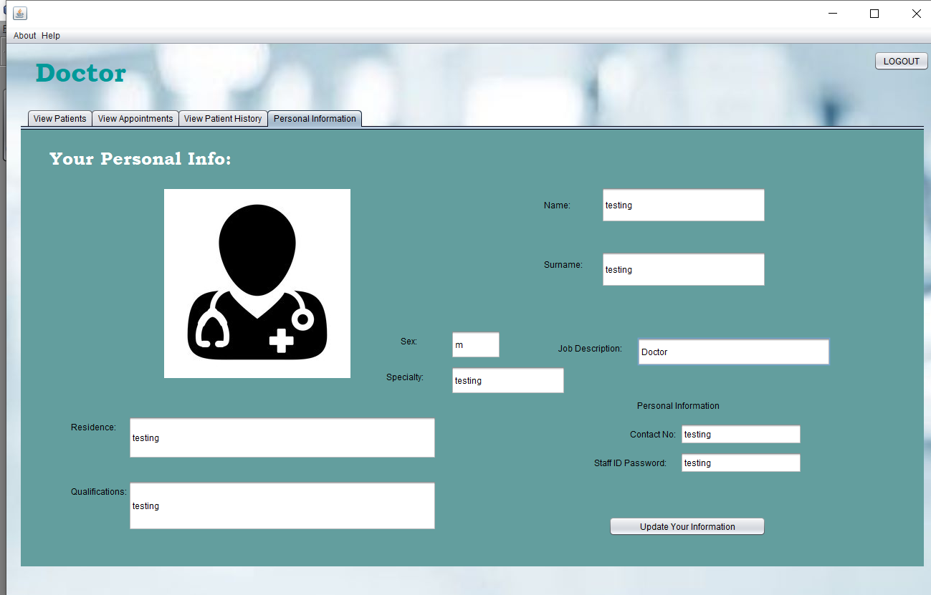

|  |  |  |
| --- | --- | --- |
| **GUI Component and Name** | **Action performed** | **Data validation required** |
| **Button:** See History of Patient | Search for all the past appointments of a specific Patient via their respective ID | Patient ID has been filled in; appropriate message will show if not carried out correctly |
| **Button:** Update Your Information | Updates the Record and Details of the logged-in user in real time | N/A |

## Pharmacist Page

### View Patients

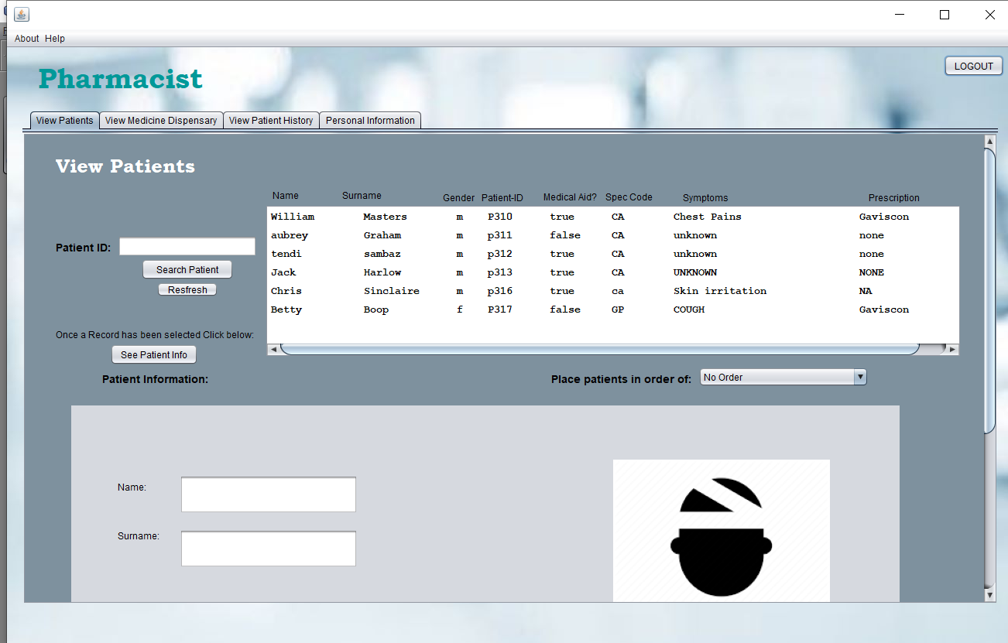

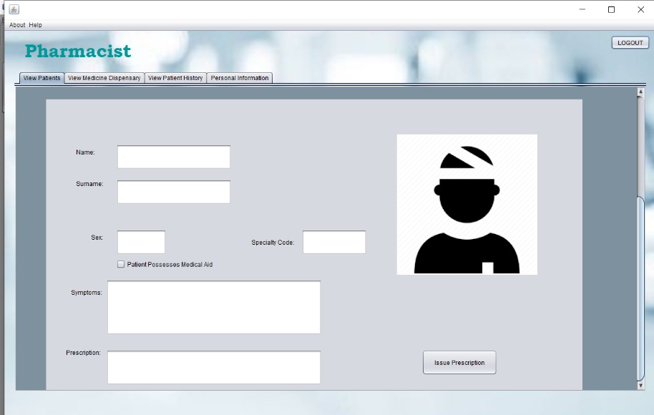

|  |  |  |
| --- | --- | --- |
| **GUI Component and Name** | **Action performed** | **Data validation required** |
| **Button:** Logout | Redirects the user back to the User Selection Page | N/A |
| **Combo Box:** PatientsOrder | Clears and re-orders the list according to desired selections | N/A |
| **Button:** Refresh | Clears the ordered list and randomly orders the list with all patients | N/A |
| **Button:** Search Patient | Searches for and displays a specific patient record in the list | Patient ID has been entered; appropriate message will show if not carried out correctly |
| **Button:** See Patient Info | Displays the selected Patient’s information in the respective fields for view | Patient record has been selected; appropriate message will show if not carried out correctly |
| **Button:** Issue Prescription | Opens the Prescription Window | N/A |

### Issue Prescription

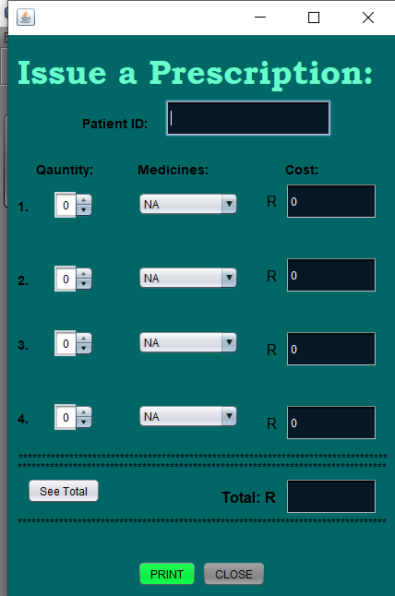

|  |  |  |
| --- | --- | --- |
| **GUI Component and Name** | **Action performed** | **Data validation required** |
| **Button:** Close | Closes the Prescription Window | N/A |
| **Spinner:** Quantity (x4) | Provides the user with a choice of how many of the Medicine they would like (Between 1 and 5) | N/A |
| **Combo Box:** Medicine (x4) | Gives the particular medicine the user would like to prescribe | N/A |
| **Button:** See Total | Displays the total of the bill in the field on the right | N/A |
| **Button:** Print | Opens a text file and prints all the prescription information in the notes in the given format | Patient ID has been entered; appropriate message will show if not carried out correctly |

### View Medicine Dispensary

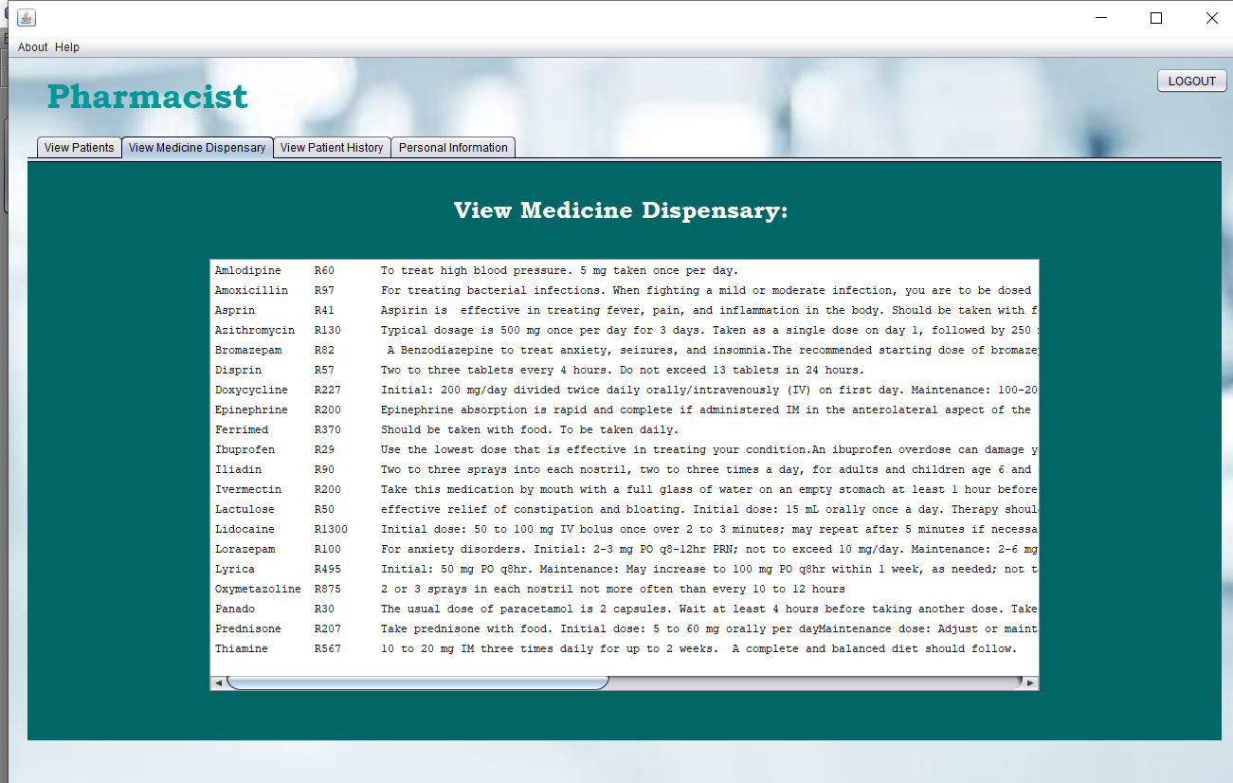

### View Patient History

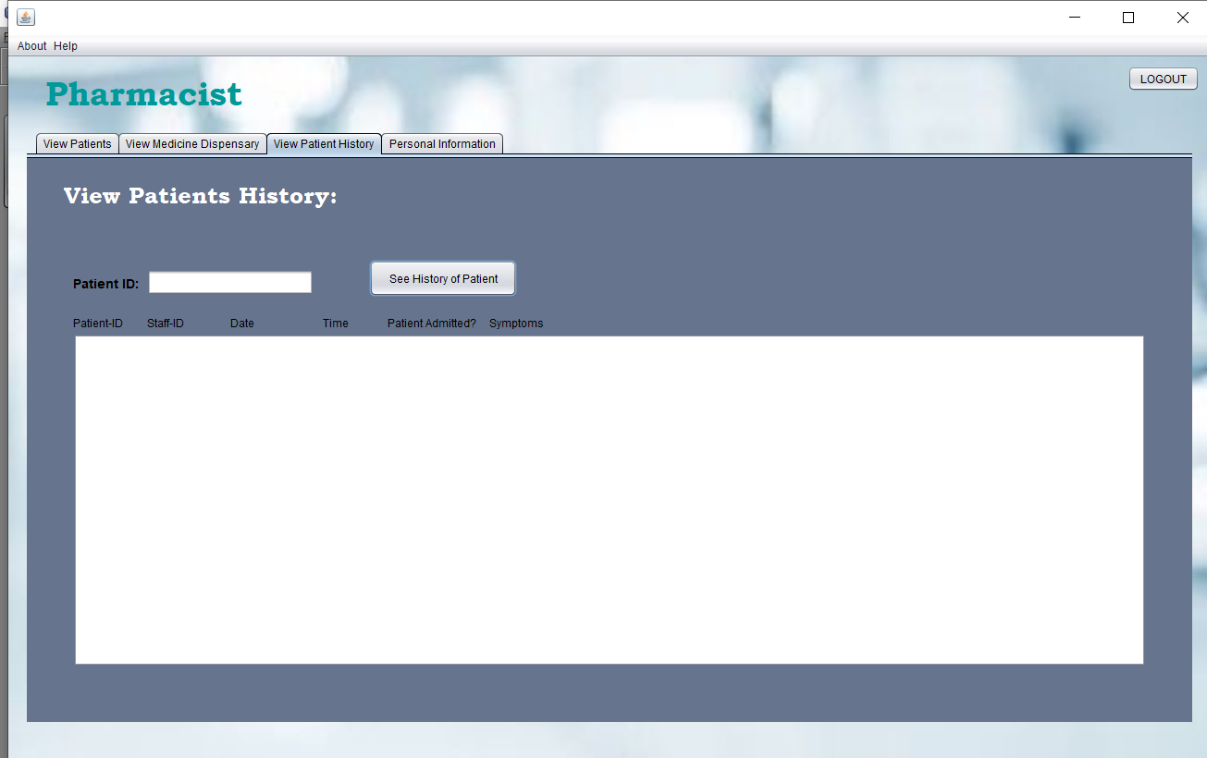

|  |  |  |
| --- | --- | --- |
| **GUI Component and Name** | **Action performed** | **Data validation required** |
| **Button:** See History of Patient | Search for all the past appointments of a specific Patient via their respective ID | Patient ID has been filled in; appropriate message will show if not carried out correctly |

### Personal Information

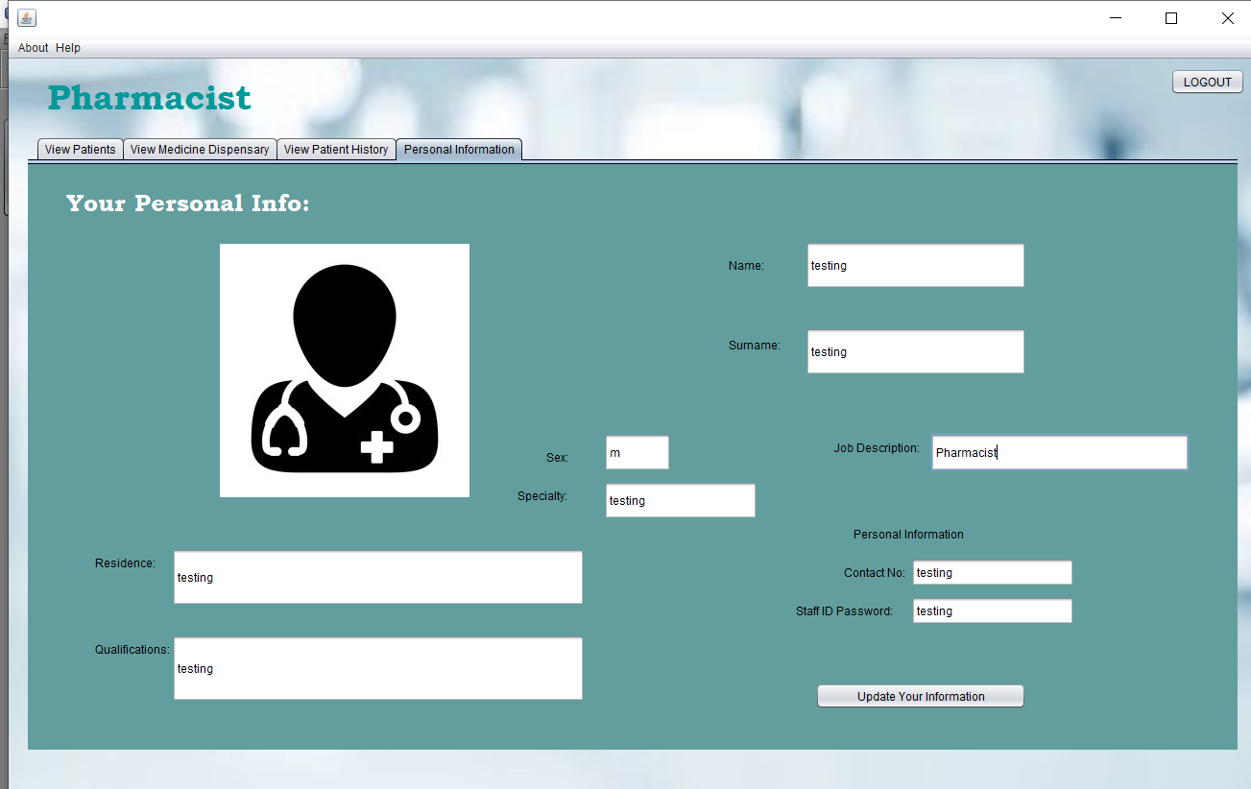

|  |  |  |
| --- | --- | --- |
| **GUI Component and Name** | **Action performed** | **Data validation required** |
| **Button:** Update Your Information | Updates the Record and Details of the logged-in user in real time | N/A |

## Receptionist Page

### View Patients

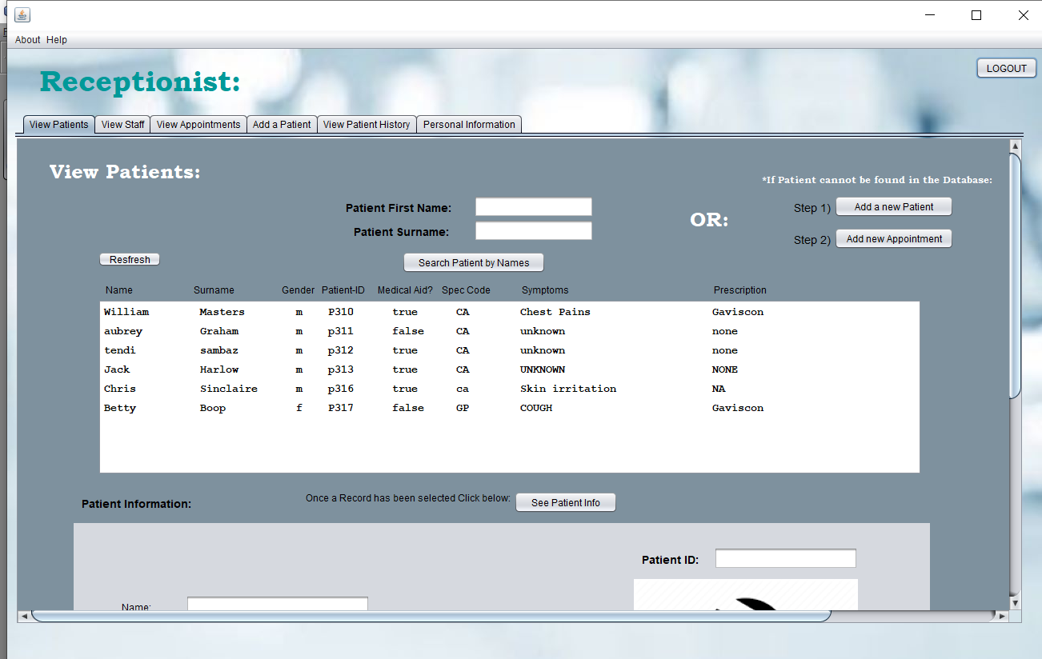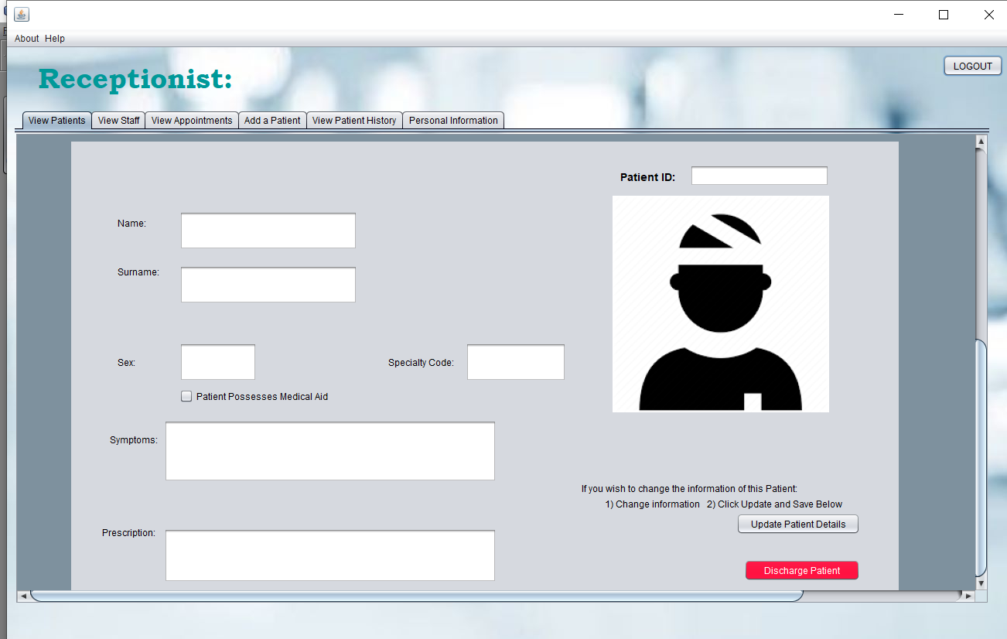

|  |  |  |
| --- | --- | --- |
| **GUI Component and Name** | **Action performed** | **Data validation required** |
| **Button:** Logout | Redirects the user back to the User Selection Page | N/A |
| **Button:** Refresh | Clears the ordered list and randomly orders the list with all patients | N/A |
| **Button:** Search Patient By Name | Searches for and displays a specific patient record in the list | Both Patient Name and Surname has been entered; appropriate message will show if not carried out correctly |
| **Button:** See Patient Info | Displays the selected Patient’s information in the respective fields for view | Patient record has been selected; appropriate message will show if not carried out correctly |
| **Button:** Update Patient | Updates the Patient’s Record and Details in real time | Patient Record has been selected; appropriate message will show if not carried out correctly |
| **Button:** Discharge Patient | Deletes the patient record that has been selected | Patient Record has been selected; appropriate message will show if not carried out correctly |
| **Button:** Add a Patient | Redirects the user back to the Add Patients tab | N/A |
| **Button:** Add an Appointment | Opens the Appointment Page | N/A |

### Add an Appointment

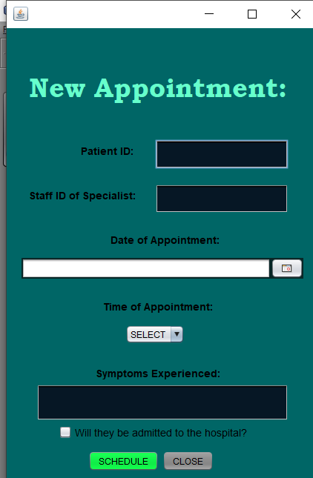

|  |  |  |
| --- | --- | --- |
| **GUI Component and Name** | **Action performed** | **Data validation required** |
| **Button:** Close | Closes the Prescription Window | N/A |
| **Combo Box:** Times | Selects the desired time for a specific appointment | N/A |
| **Button:** Schedule | Adds the appointment to the list of records | Patient ID, Specialist ID and Symptoms Fields are filled. Combo Box has a valid selection. Date of a appointment has been selected. Appropriate message will show if not carried out correctly |
| **Button:** Close | Closes the Prescription Window | N/A |
| **Date Chooser:** Date | Produces a date that the user has selected | N/A |

### View Staff

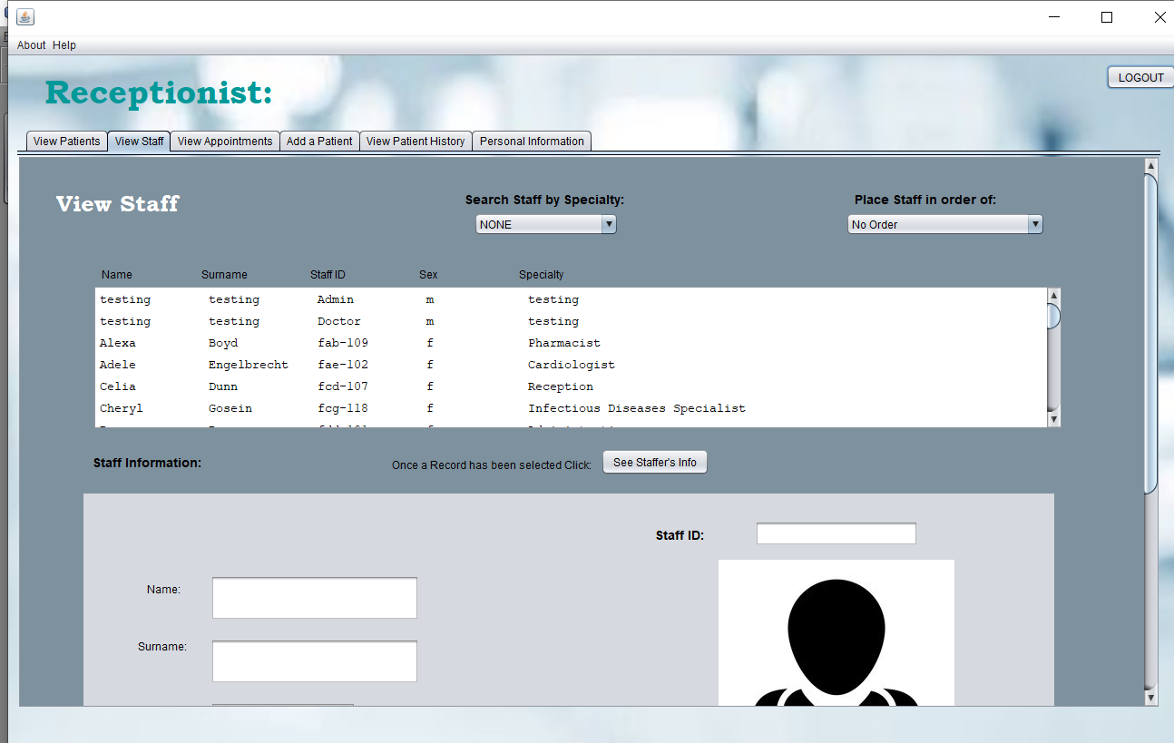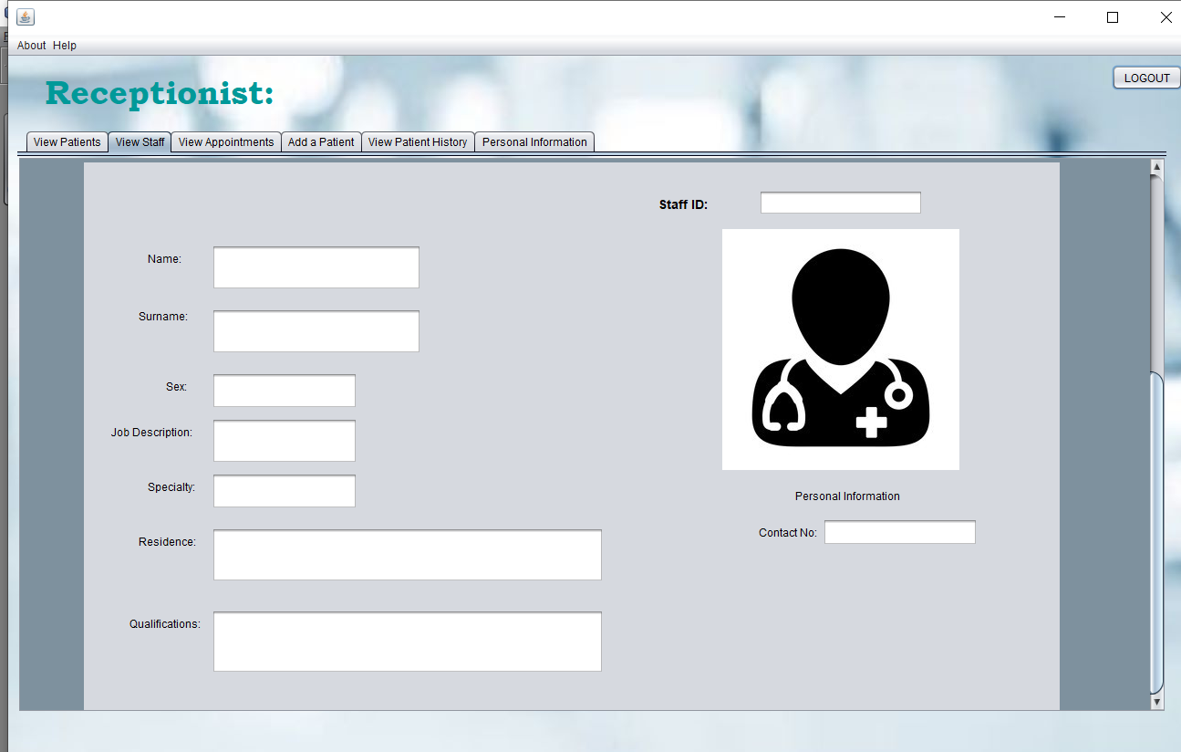

|  |  |  |
| --- | --- | --- |
| **GUI Component and Name** | **Action performed** | **Data validation required** |
| **Button:** Logout | Redirects the user back to the User Selection Page | N/A |
| **Combo Box:** Specialty | Displays the Staff according to desired Speciality choice | N/A |
| **Combo Box:** Order Staff | Displays the Staff according to desired parameters | N/A |
| **Button:** See Staff Info | Displays the selected Staff information in the respective fields for view | Staff record has been selected; appropriate message will show if not carried out correctly |

### View Appointments

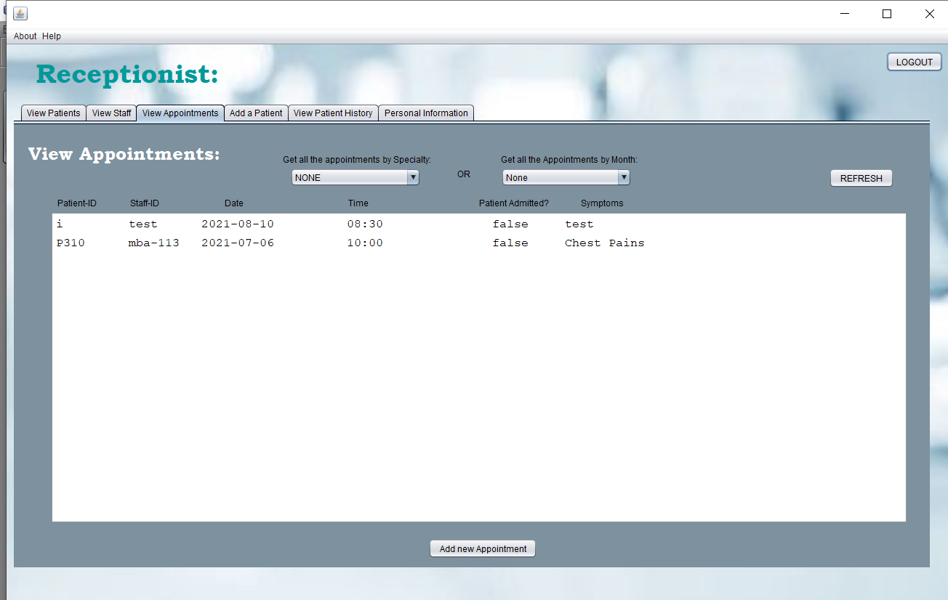

|  |  |  |
| --- | --- | --- |
| **GUI Component and Name** | **Action performed** | **Data validation required** |
| **Combo Box:** Monthly Order | Clears and re-orders the Appointments according to desired Month of the year | N/A |
| **Combo Box:** Specialty Order | Clears and re-orders the Appointments according to desired Specialty | N/A |
| **Button:** Refresh | Displays all the appointments in no particular order | N/A |
| **Button:** Add an Appointment | Opens the Appointment Page | N/A |

### View Add a Patient

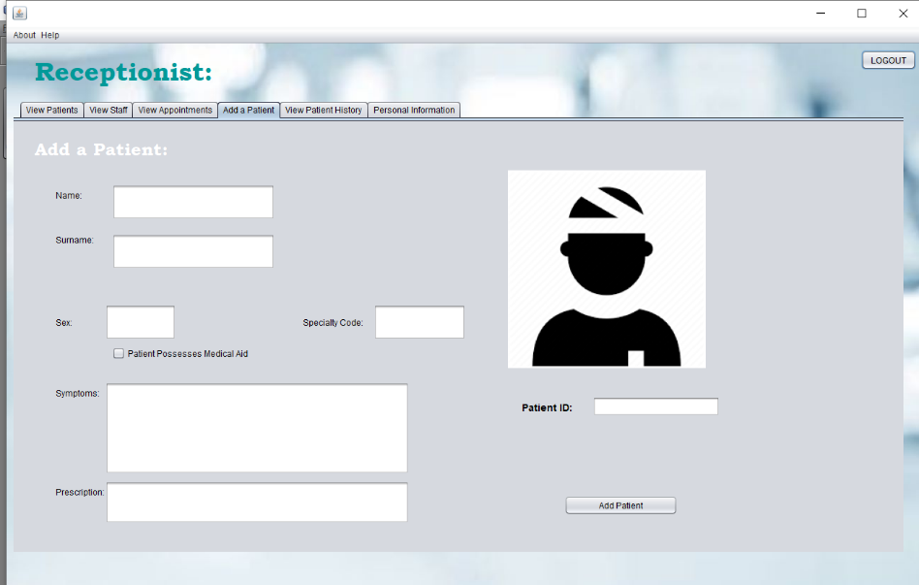

|  |  |  |
| --- | --- | --- |
| **GUI Component and Name** | **Action performed** | **Data validation required** |
| **Button:** Add Patient | Compiles all entered information into a new record and adds it to the records list | All fields are filled; . Appropriate message will show if not carried out correctly |

### View Patient History

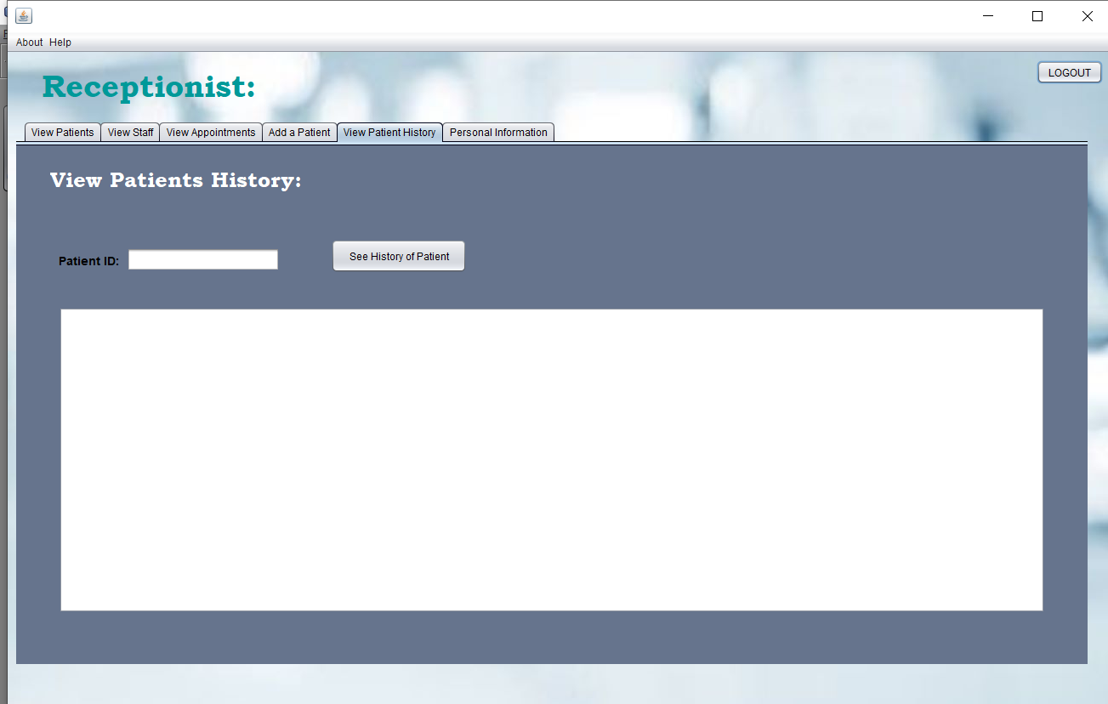

|  |  |  |
| --- | --- | --- |
| **GUI Component and Name** | **Action performed** | **Data validation required** |
| **Button:** See History of Patient | Search for all the past appointments of a specific Patient via their respective ID | Patient ID has been filled in; appropriate message will show if not carried out correctly |

### Personal Information

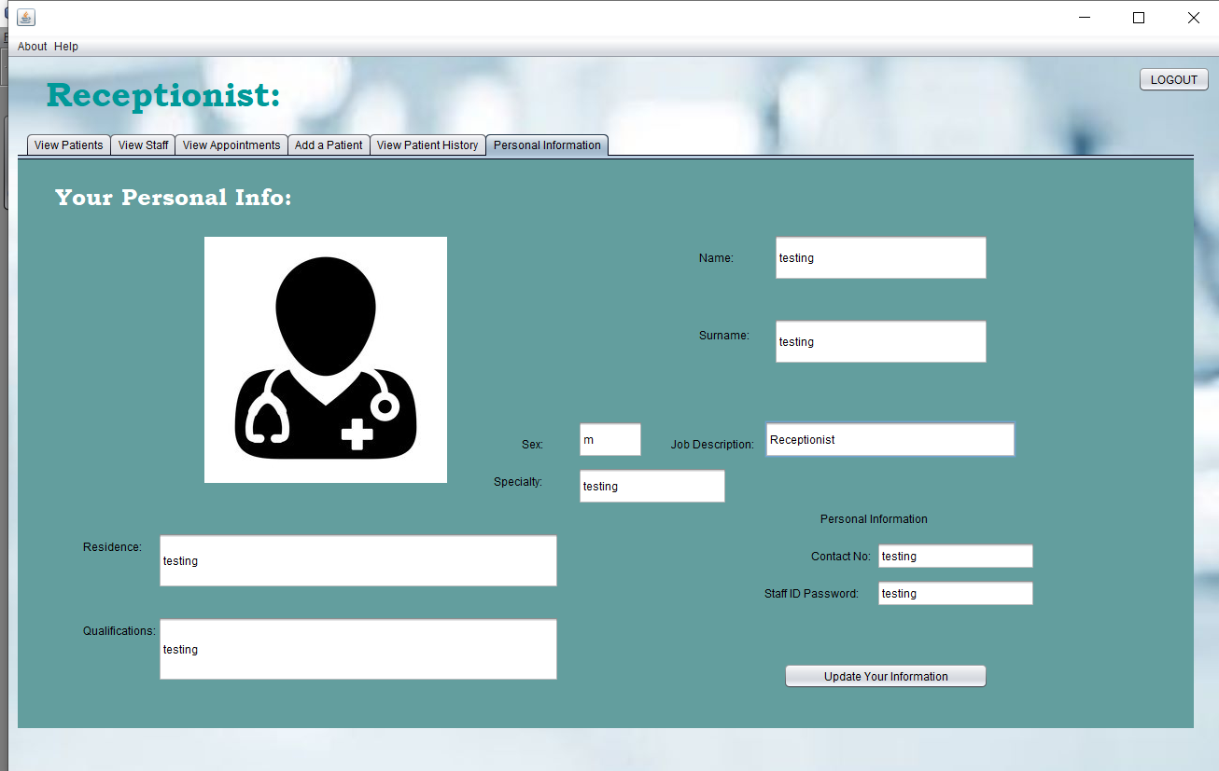

|  |  |  |
| --- | --- | --- |
| **GUI Component and Name** | **Action performed** | **Data validation required** |
| **Button:** See History of Patient | Search for all the past appointments of a specific Patient via their respective ID | Patient ID has been filled in; appropriate message will show if not carried out correctly |
| **Button:** Update Your Information | Updates the Record and Details of the logged-in user in real time | N/A |

## Administrator Page

### View Patients

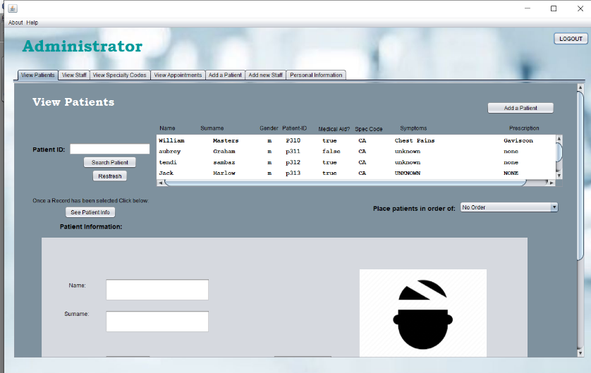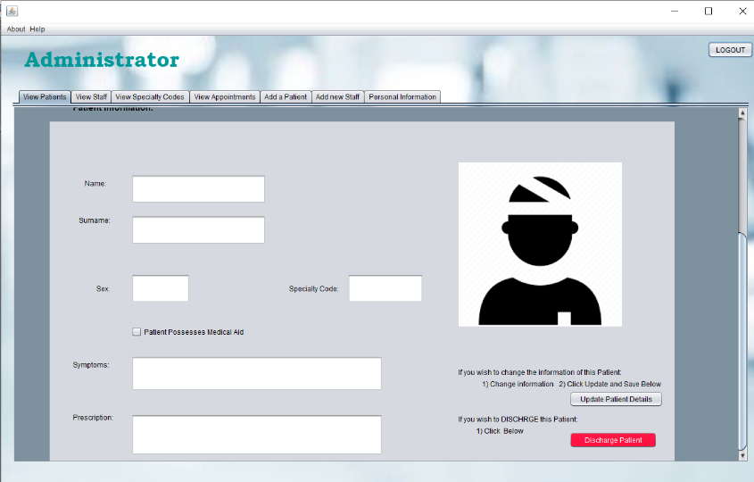

|  |  |  |
| --- | --- | --- |
| **GUI Component and Name** | **Action performed** | **Data validation required** |
| **Button:** Logout | Redirects the user back to the User Selection Page | N/A |
| **Combo Box:** PatientsOrder | Clears and re-orders the list according to desired selections | N/A |
| **Button:** Refresh | Clears the ordered list and randomly orders the list with all patients | N/A |
| **Button:** Search Patient | Searches for and displays a specific patient record in the list | Patient ID has been entered; appropriate message will show if not carried out correctly |
| **Button:** See Patient Info | Displays the selected Patient’s information in the respective fields for view | Patient record has been selected; appropriate message will show if not carried out correctly |
| **Button:** Update Patient | Updates the Patient’s Record and Details in real time | Patient Record has been selected; appropriate message will show if not carried out correctly |
| **Button:** Add a Patient | Redirects the user back to the Add Patients tab | N/A |
| **Button:** Discharge Patient | Deletes the patient record that has been selected | Patient Record has been selected; appropriate message will show if not carried out correctly |

### View Staff

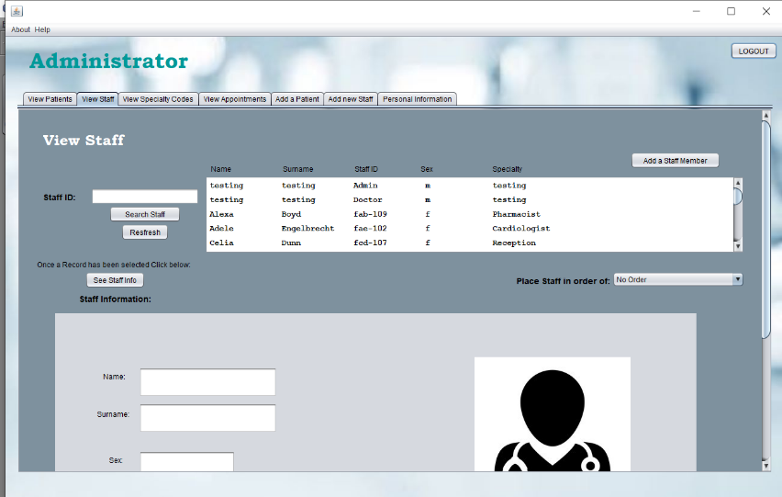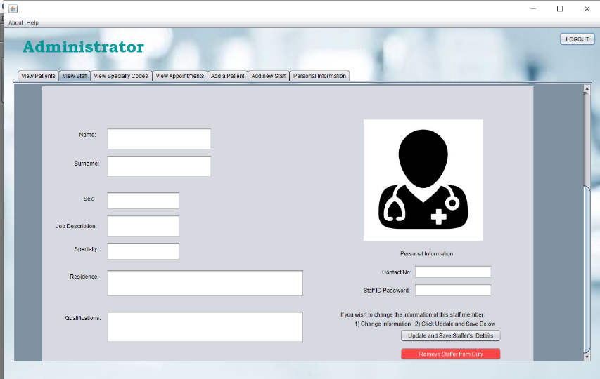

|  |  |  |
| --- | --- | --- |
| **GUI Component and Name** | **Action performed** | **Data validation required** |
| **Button:** Logout | Redirects the user back to the User Selection Page | N/A |
| **Combo Box:** StaffOrder | Clears and re-orders the list according to desired selections | N/A |
| **Button:** Remove Staff Member from Duty | Deletes the Staff record that has been selected from the list of records | Staff Record has been selected; appropriate message will show if not carried out correctly |
| **Button:** See Staff Info | Displays the selected Staff information in the respective fields for view | Staff record has been selected; appropriate message will show if not carried out correctly |
| **Button:** Add new Saff Member | Redirects User to the Add new Staff tab | N/A |
| **Button:** Search Patient | Searches for and displays a specific patient record in the list | Patient ID has been entered; appropriate message will show if not carried out correctly |
| **Button:** Refresh | Clears the ordered list and randomly orders the list with all patients | N/A |
| **Button:** Update Staff and Save Details | Updates the Staffer’s Record and Details in real time | Staff Record has been selected; appropriate message will show if not carried out correctly |

### View Specialty Codes

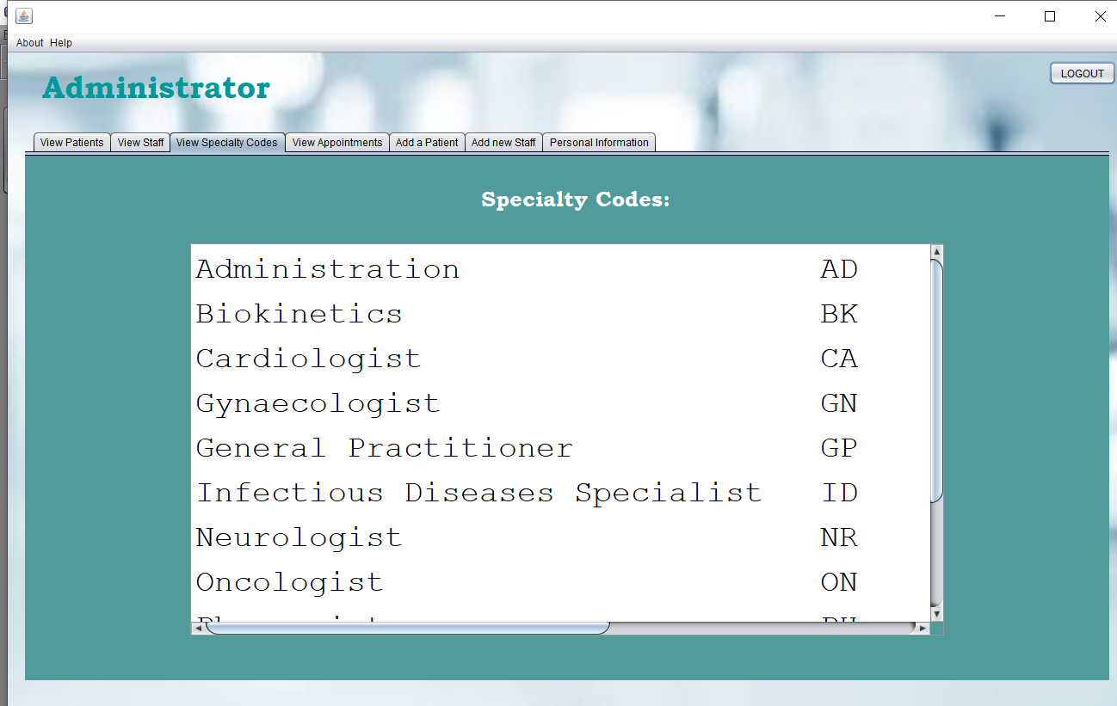

### View Appointments

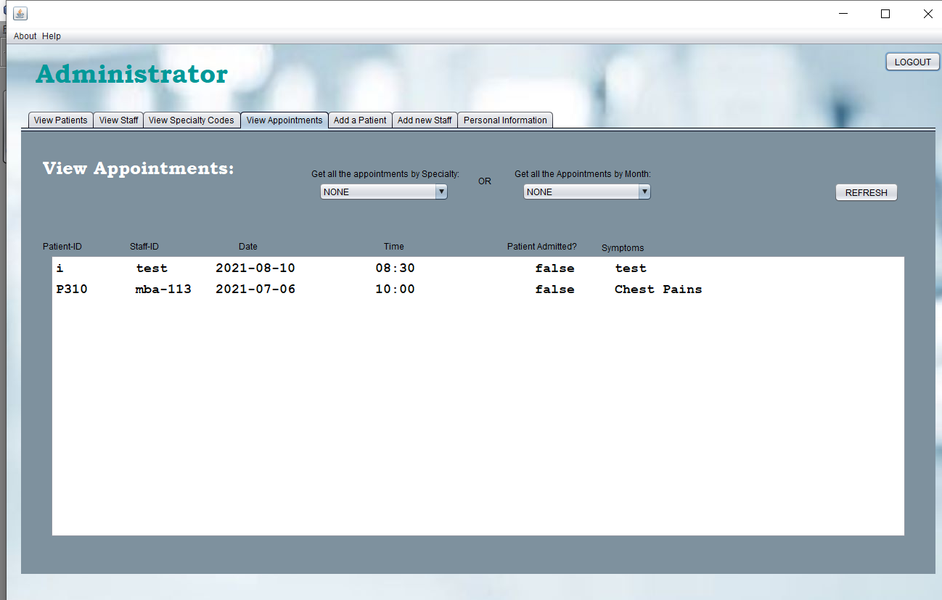

|  |  |  |
| --- | --- | --- |
| **GUI Component and Name** | **Action performed** | **Data validation required** |
| **Combo Box:** Monthly Order | Clears and re-orders the Appointments according to desired Month of the year | N/A |
| **Combo Box:** Specialty Order | Clears and re-orders the Appointments according to desired Specialty | N/A |
| **Button:** Refresh | Displays all the appointments in no particular order | N/A |

### Add new Patient

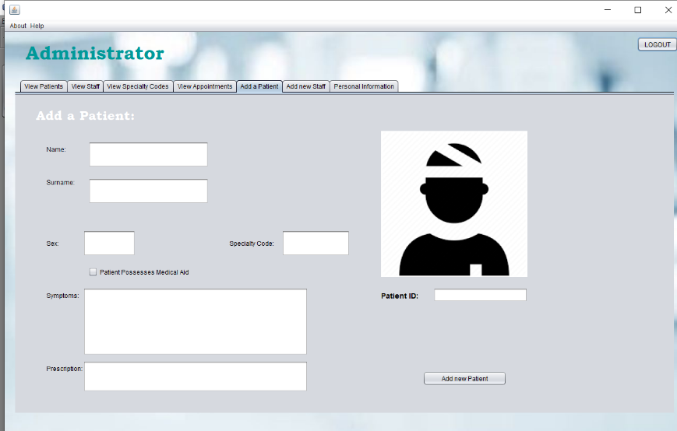

|  |  |  |
| --- | --- | --- |
| **GUI Component and Name** | **Action performed** | **Data validation required** |
| **Button:** Add Patient | Compiles all entered information into a new record and adds it to the records list | All fields are filled; . Appropriate message will show if not carried out correctly |

### Add New Staff

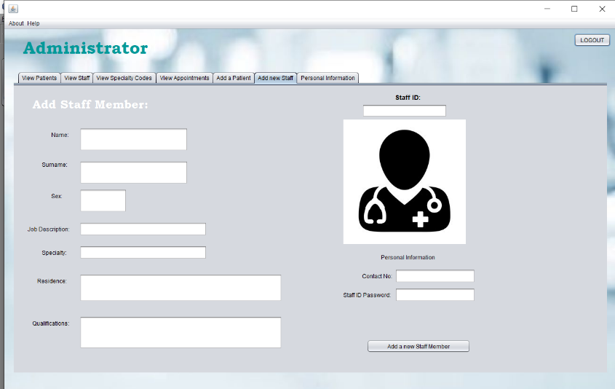

|  |  |  |
| --- | --- | --- |
| **GUI Component and Name** | **Action performed** | **Data validation required** |
| **Button:** Add Staff Member | Compiles all entered information into a new record and adds it to the records list | All fields are filled; . Appropriate message will show if not carried out correctly |

### Personal Information

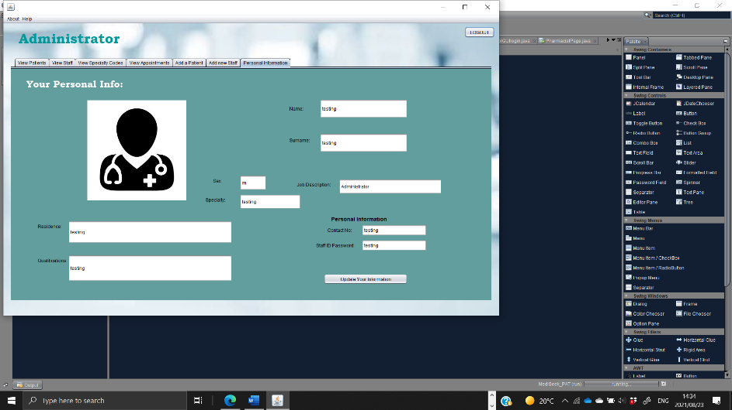

|  |  |  |
| --- | --- | --- |
| **GUI Component and Name** | **Action performed** | **Data validation required** |
| **Button:** Update Your Information | Updates the Record and Details of the logged-in user in real time | N/A |

**Program Flow and Sequencing**

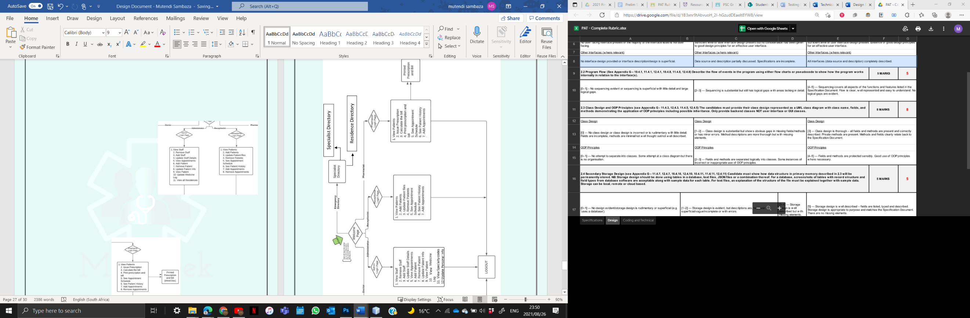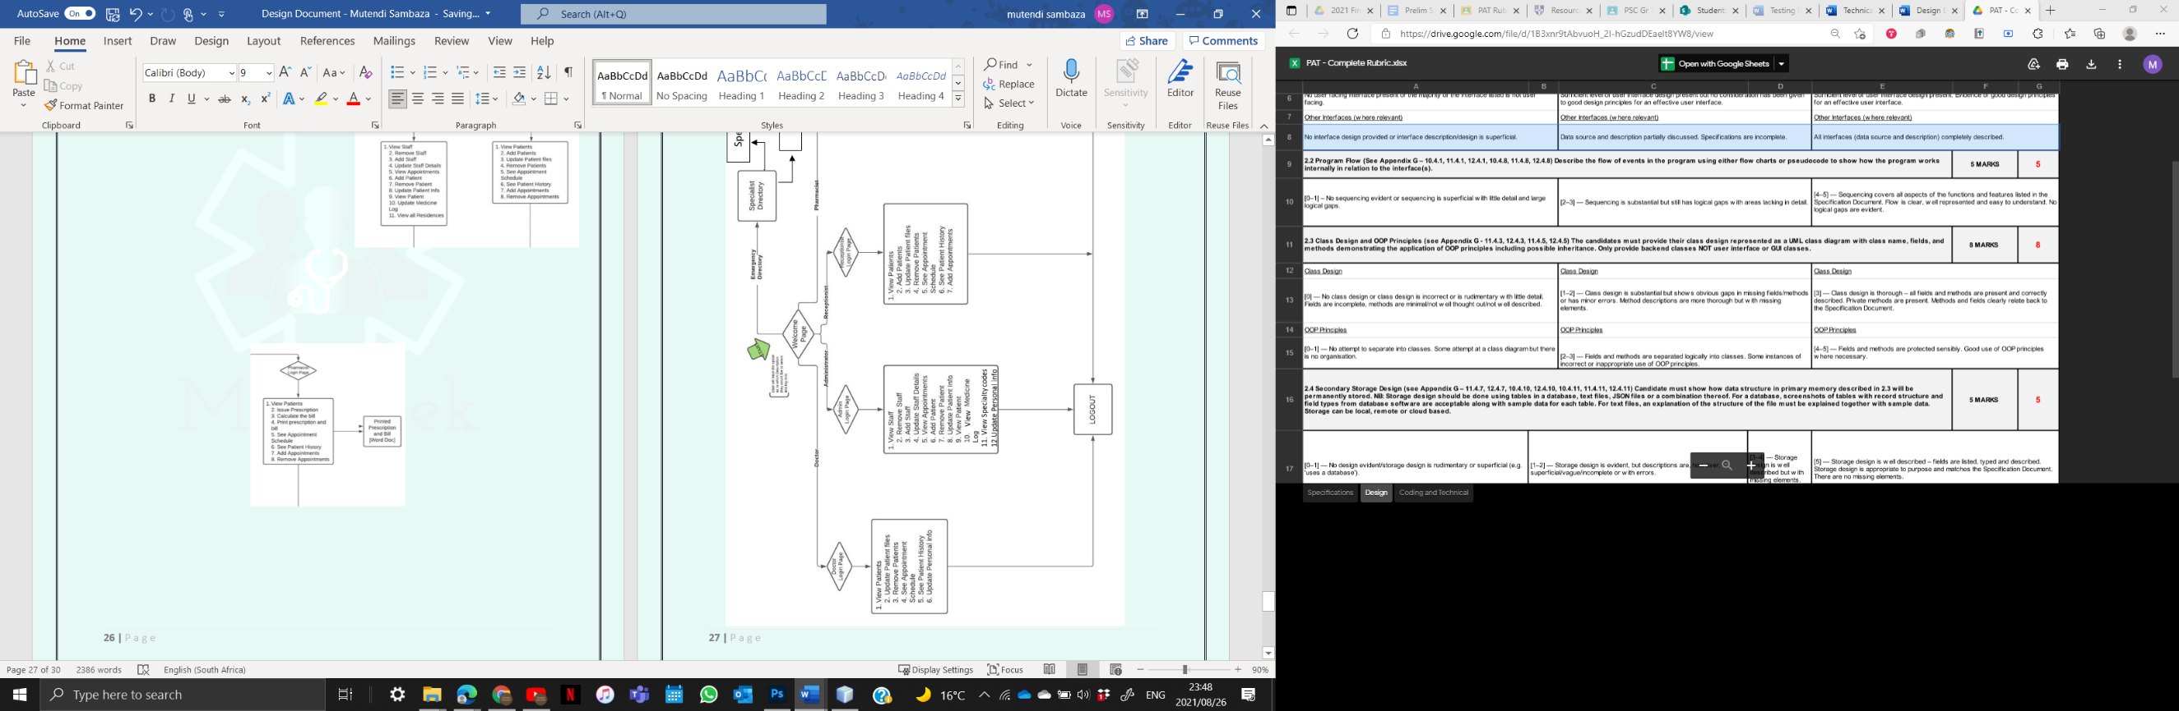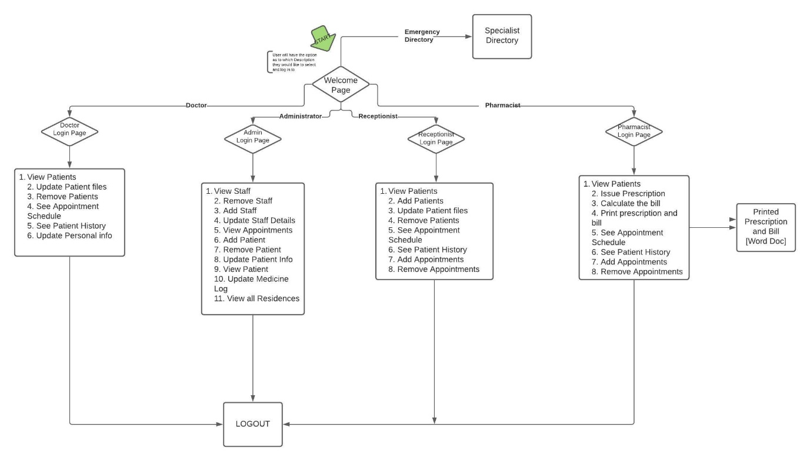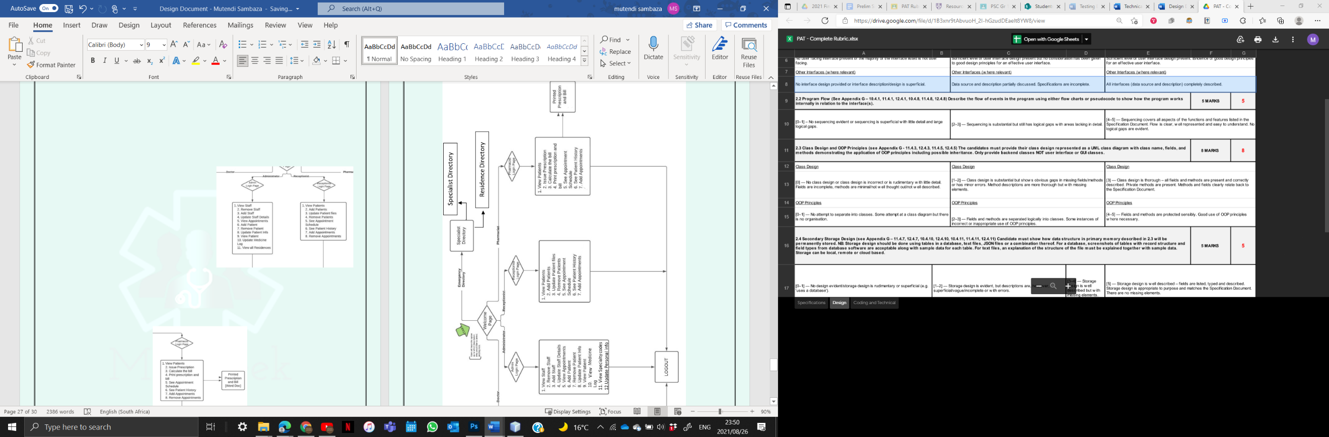

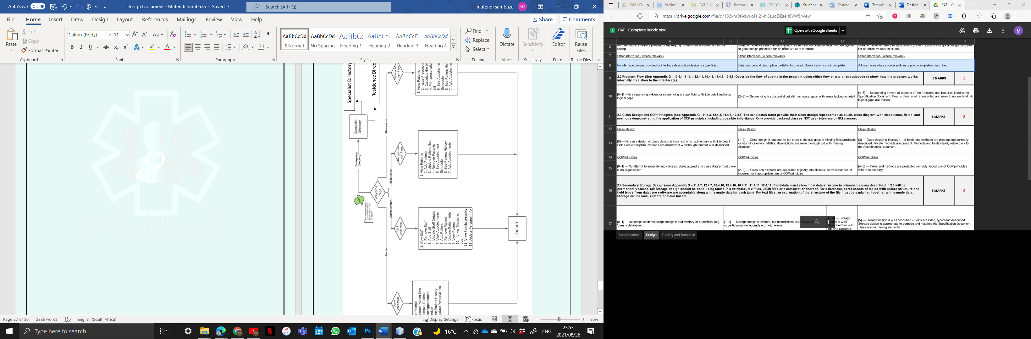



Residence Directory Directory

Specialist Directory



11. View Specialty codes

12.Update Personal info

View



# **Class Diagrams**

|  |
| --- |
| **Staff** |
| * String sName; * String sSurname; * String gender; * String jobDescription; * String specialty; * String residence; * String qualifications; * String contact; * String staff_ID; * String password   Field Variables |
| + Constructor (String sName, String sSurname, String gender, String jobDescription, String specialty, String residence, String qualifications, String contact, String staff_ID, String password) à initialises field variables  + getsName() String  + getsSurname() String  + getGender() String  + getJobDescription(): String  + getSpecialty(): String  + getResidence(): String  + getQualifications(): String  + getContact(): String  + getStaff_ID(): String  + getPassword(): String  - addSpaces(int x, String y) : String  - used to get fixed column widths based on y values  + toString(): String |

|  |
| --- |
| **UseStaff** |
| * int size; * Staff[] staffMember; à array of objects |
| + fromtblStaff(String SQL): Staff [] à method retrieves all data from access and fills the array of objects  + getSize(): int à returns size of array of objects  + updateTable(String update) à executes insert, update and delete statements in SQL |

|  |
| --- |
| **P**atients |
| * String name; * String surname; * String gender; * String boolean medicalAid; * String specialtyCode; * String diagnosis; * String prescription; * String contact;   Field Variables |
| + Constructor (String name, String surname, String gender, String patientID, boolean medicalAid, String specialtyCode, String diagnosis, String prescription) à initialises field variables  + getName() String  + getSurname() String  + getGender() String  + getPatientID (): String  + getSpecialtyCode(): String  + isMedicalAid (): boolean  + getDiagnosis (): String  + getPrescription (): String  - addSpaces(int x, String y) : String  - used to get fixed column widths based on y values  + toString(): String |

|  |
| --- |
| **UsePatients** |
| * int size; * Patients [] patients; à array of objects |
| + fromtblPatients(String SQL): Patients [] à method retrieves all data from access and fills the array of objects  + getSize(): int à returns size of array of objects  + updateTable(String update) à executes insert, update and delete statements in SQL |

|  |
| --- |
| **Medicine** |
| * String medicine; * String usageDescription; * int cost;   Field Variables |
| + Constructor (String medicine, String usageDescription, String cost) à initialises field variables  + getMedicine() String  + getUsageDescription () String  + getCost () int  - addSpaces(int x, String y) : String  - used to get fixed column widths based on y values  + toString(): String |

|  |
| --- |
| **UseMedicine** |
| * int size; * Medicine [] med; à array of objects |
| + fromtblMedicine (String SQL): Medicine [] à method retrieves all data from access and fills the array of objects  + getSize(): int à returns size of array of objects  + updateTable(String update) à executes insert, update and delete statements in SQL |

|  |
| --- |
| **Appointments** |
| * String patientNo; * String staffID; * LocalDate appDate; * String appTime; * boolean admission; * String symptoms;   Field Variables |
| + Constructor (String patientNo, String staffID, LocalDate appDate, String appTime, boolean admission, String symptoms) à initialises field variables  + getPatientNo () String  + getStaffID() String  + getAppDate() String  + getAppTime(): String  + isAdmission(): boolean  + getSymptoms (): String  + getQualifications(): String  + getContact(): String  + getStaff_ID(): String  + getPassword(): String  - addSpaces(int x, String y) : String  - used to get fixed column widths based on y values  + toString(): String |

|  |
| --- |
| **UseAppointments** |
| * int size; * Appointments[] ap; à array of objects |
| + fromtblAppointments(String SQL): Appointments[] à method retrieves all data from access and fills the array of objects  + getSize(): int à returns size of array of objects  + updateTable(String update) à executes insert, update and delete statements in SQL |

|  |
| --- |
| **directory** |
| * String sName; * String sSurname; * String gender; * String jobDescription; * String specialty; * String residence; * String qualifications; * String contact; * String staff_ID;   Field Variables |
| + Constructor (String sName, String sSurname, String gender, String jobDescription, String specialty, String residence, String qualifications, String contact, String staff_ID) à initialises field variables  + getsName () String  + getsSurname() String  + getGender() String  + getJobDescription(): String  + getSpecialty(): String  + getResidence(): String  + getQualifications(): String  + getContact(): String  + getStaff_ID(): String  - addSpaces(int x, String y) : String  - used to get fixed column widths based on y values  + toString(): String |

|  |
| --- |
| **UseDirectory** |
| * int size; * directory[] staffDirectory; à array of objects |
| + fromtblDirectory (String SQL): directory [] à method retrieves all data from access and fills the array of objects  + getSize(): int à returns size of array of objects  + updateTable(String update) à executes insert, update and delete statements in SQL |

|  |
| --- |
| **Specialty** |
| * String specialty; * String specialtyCode;   Field Variables |
| + Constructor (String specialty, String specialtyCode) à initialises field variables  + getSpecialty () String  + getSpecialtyCode () String  - addSpaces(int x, String y) : String  - used to get fixed column widths based on y values  + toString(): String |

|  |
| --- |
| **UseSpecialty** |
| * int size; * Specialty[] spec; à array of objects |
| + fromtblSpecialty (String SQL): Specialty [] à method retrieves all data from access and fills the array of objects  + getSize(): int à returns size of array of objects  + updateTable(String update) à executes insert, update and delete statements in SQL |

|  |
| --- |
| **ForConnecting** |
| **+**Connection conn |
| + Constructor() |

|  |
| --- |
| **Data Validation** |
| + isNotEmpty(String inp): boolean à Method used to check if text fields contain any characters at all  + allCharacters(String inp): boolean à Method checks to see if the value within the parameters is are all letters.  + isValidNumber(String inp): boolean à Method checks to see if the value within the parameters is all numbers. |

|  |
| --- |
| Methods |
| + openSite (String site): void à method takes the string and enters it as a search in a default browser  + openWord(String docName): voidà method opens any document that has the file name docName  + writeToReciept (String name, String surname,  String item1, String item2, String item3, String item4,  int quan1, int quan2, int quan3, int quan4,  int cost1, int cost2, int cost3, int cost4,int total,  String instr1, String instr2, String instr3, String instr4) à method all these parameter values, opens a text file and inputs them in a set format to produce a receipt |

# **Persistent Storage Design**

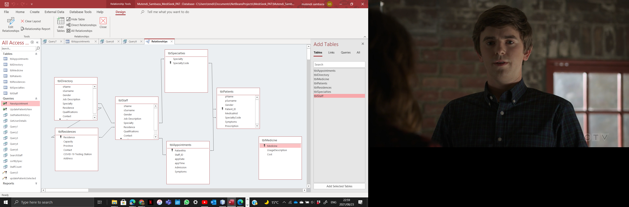

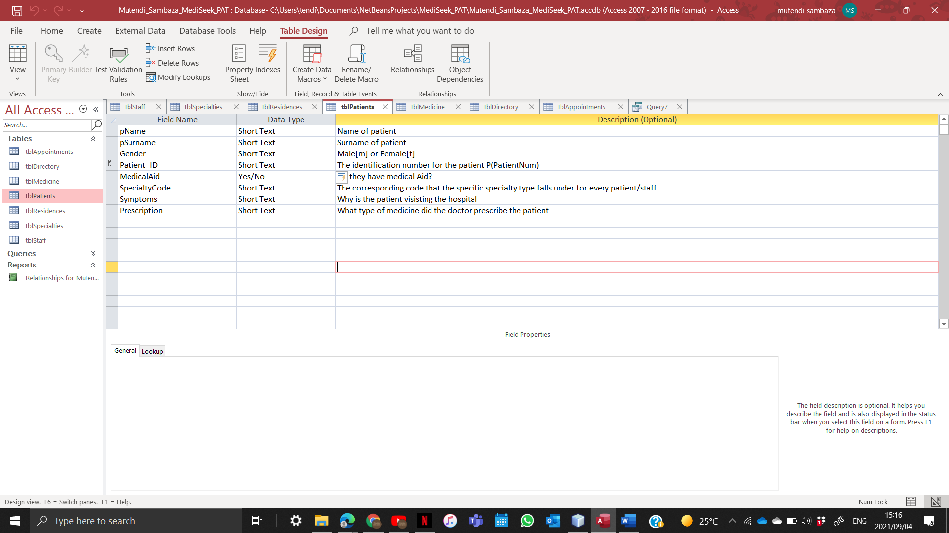

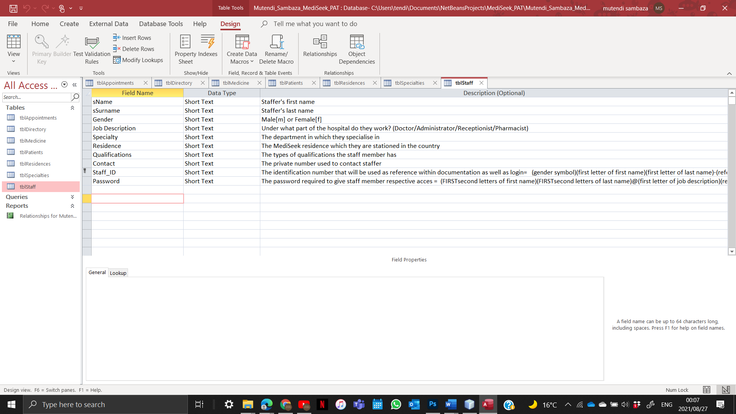

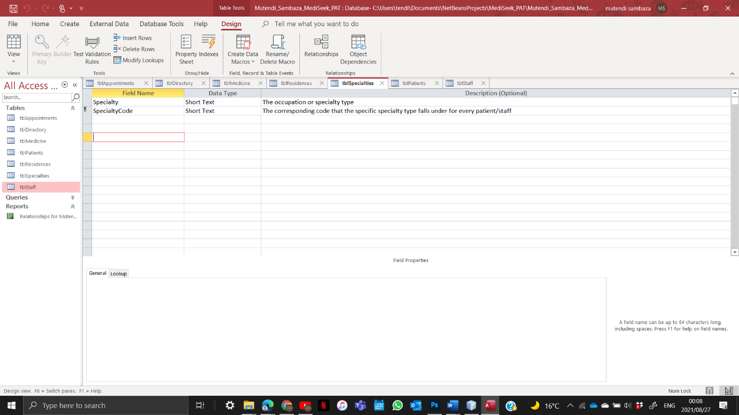

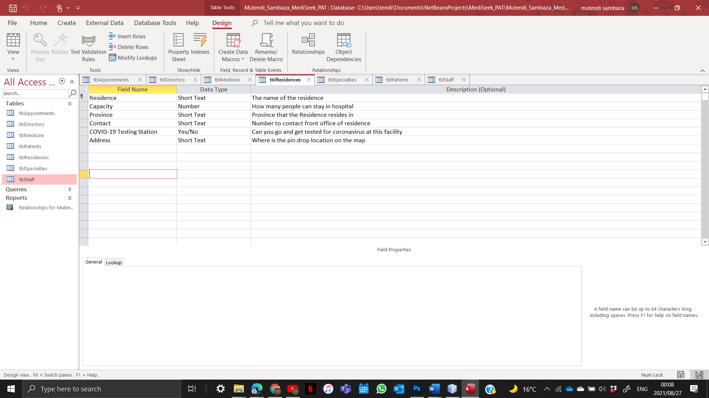

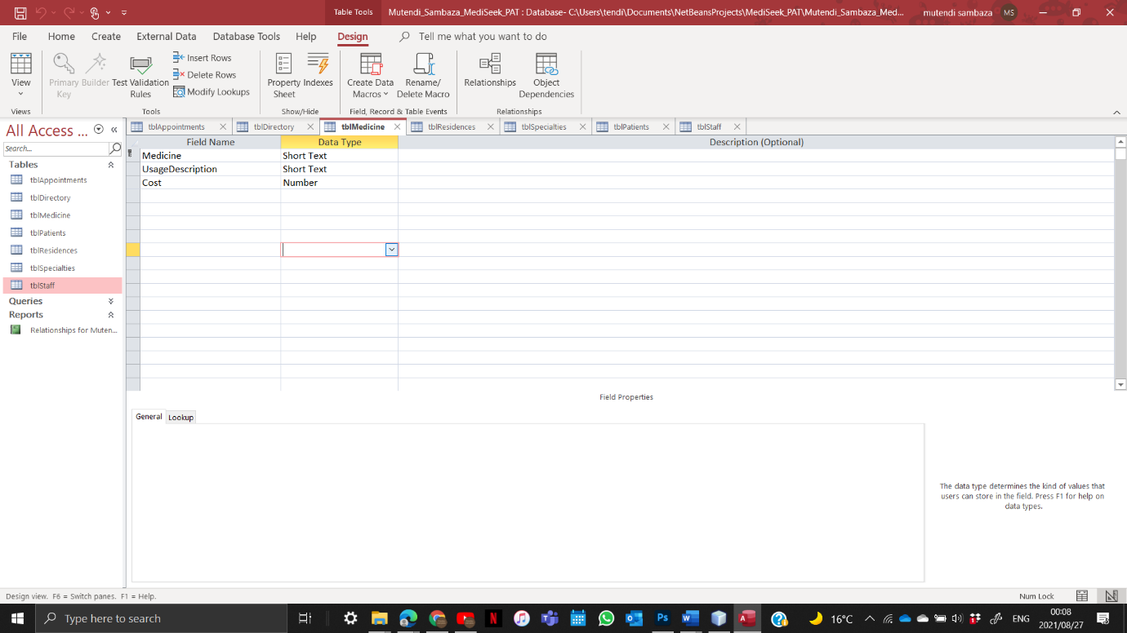

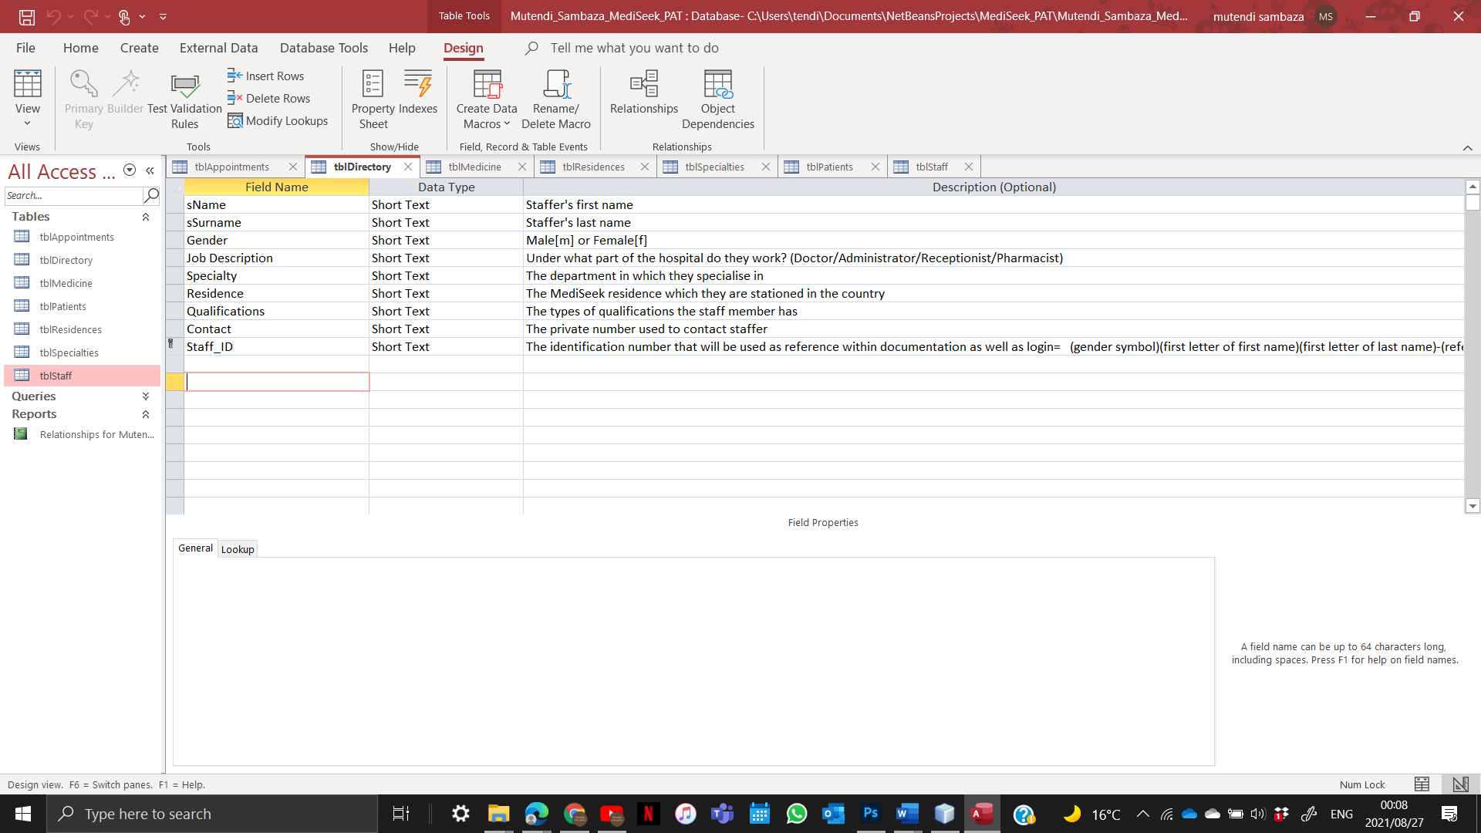

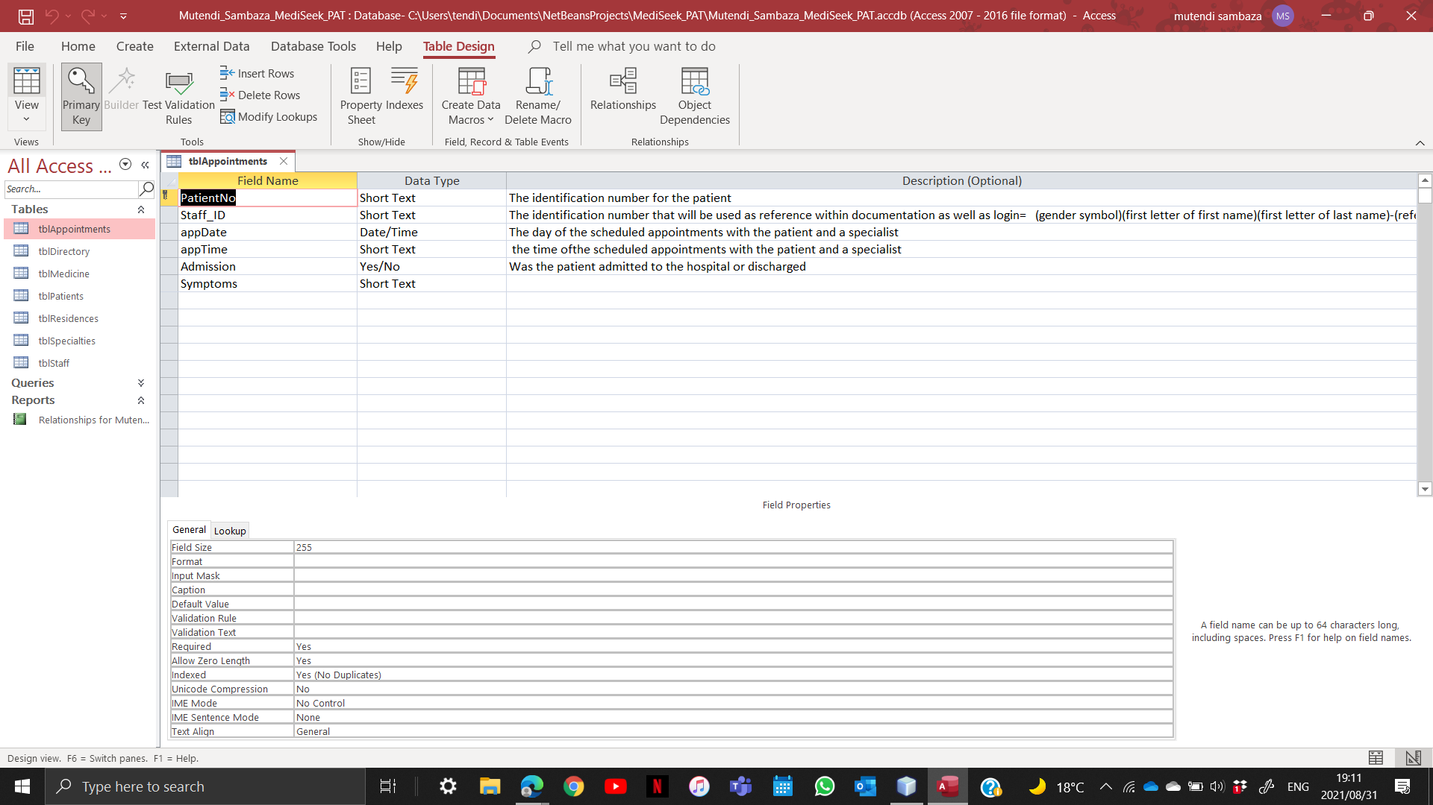

# **Explanation of Secondary Storage Design**

MediSeek HMS has its data stored in a database as the size of the data is very large and will be constantly growing within its categorized forms. Based on the type of data captured, it can be structured logically and worked on with ease while still managing to maintain its meaning within its sets. Using databases allows the program to work more efficiently by increasing security and by avoiding things like redundancy and data loss.

The HMS makes use of Microsoft Access as the secondary storage and database management tool. Understanding that the data kept is made of many fields and correlations which are to be manipulated and interacted with within their tables of origin. It is perfect because the way it displays information is very digestible and easy to read as a user omitting random columns and formats. It also is able to collect data and access that data easily. With the use of queries and its well-integrated functions it allows for very specific pieces of information.

The Netbeans IDE, once run, can also easily access Access; both small and large quantities of information at a time.

# **Explanation of Primary Data Structure Related to Secondary Storage**

### tblStaff

An array of Staff, “staffMember”, comprised of 10 variables stores the data from the table tblStaff accessed using the method “fromtblStaff”

### tblPatients

An array of Patients, “patients”, comprised of 8 variables stores the data from the table tblPatients accessed using the method “fromtblPatients”

### tblAppointments

An array of Appointments, “ap”, comprised of 6 variables stores the data from the table tblAppointments accessed using the method “fromtblAppointments”

### tblDirectory

An array of Directory, “staffDirectory”, comprised of 9 variables stores the data from the table tblDirectory accessed using the method “fromtblDirectory”

### tblMedicine

An array of Medicine, “med”, comprised of 3 variables stores the data from the table tblMedicine accessed using the method “fromtblMedicine”

### tblResidence

An array of Residences, “res”, comprised of 6 variables stores the data from the table tblResidence accessed using the method “fromtblResidences”

### tblSpecialty

An array of Specialty, “spec”, comprised of 2 variables stores the data from the table tblSpecialty accessed using the method “fromtblSpecialty”